**Step1: IP Addressing**

**Puppet MasterServer:**

Running on Other VM Ware Machine which is on same network (Note: Can able to ping other puppet agent, Puppet Client ip,etc).

Server IP: ***192.168.0.108***

Server Host Name: ***chakriserver***

**

**

**Ping the Puppet Agent IP from the Puppet MasterServer:**

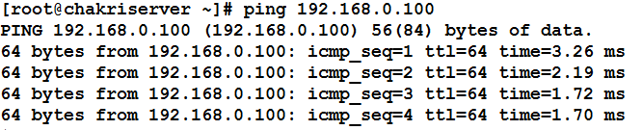

**Ping the Puppet Agent IP from the Puppet MasterServer:**

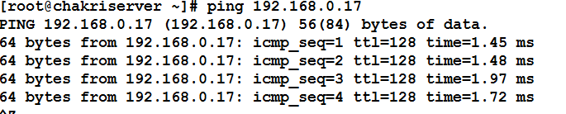

**Puppet Agent:**

Puppet Agent IP: ***192.168.0.100***



Puppet Agent Host Name: ***Puppet-Workstation***

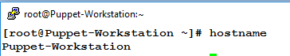

**Ping the Puppet Server IP from the Puppet Agent:**

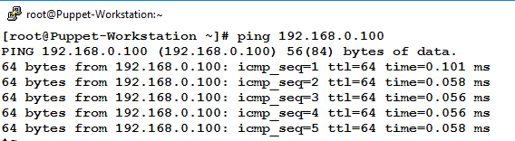

**Step2: Puppet MasterServer Configuration**

Install the Puppet, repository by executing following command (RPM file name can change with new release):

On CentOS/RHEL 6.5:

# rpm -ivh https://yum.puppetlabs.com/el/6.5/products/x86_64/puppetlabs-release-6-10.noarch.rpm

On CentOS/RHEL 7:

# rpm -ivh https://yum.puppetlabs.com/el/7/products/x86_64/puppetlabs-release-7-10.noarch.rpm

**Yum Install Puppet -server**

**Yum Clean all (both Server and client )**

**Setenforce =0**

**Vi /etc/hosts**

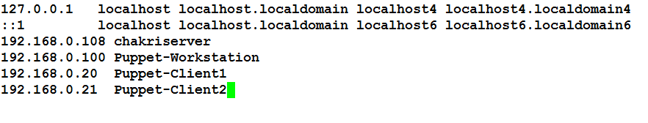

/etc/init.d/puppet restart

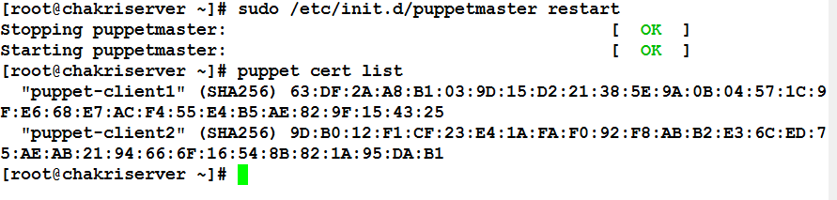





**Writing the manifesto file**

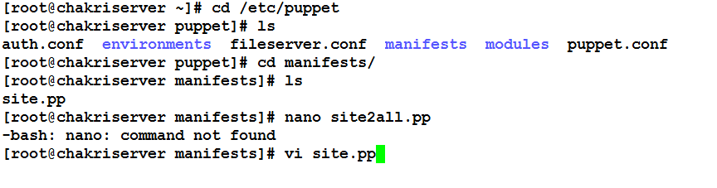

Only Extension .pp allowed

Apply the manifest file

*Puppet apply site.pp #* (file name)